Genghis Khan Homework
You need to choose another famous leader from history. Your homework task is to produce a one page fact file on this person and their achievements in your jotters.

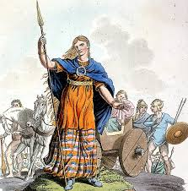
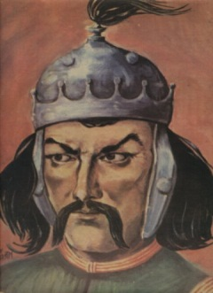
Suggestions
- Alexander the Great
- Julius Caesar
- Attila the Hun
- Joan of Arc
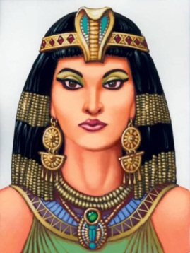
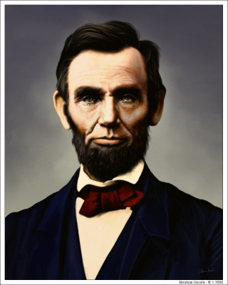
- Napoleon Bonaparte
- Josef Stalin
- Boudicea
- Abraham Lincoln
- Cleopatra
- Hannibal
- Or one of your choice

You should use the following headings-
1. When and where they were born
2. How they became a leader
3. Their greatest achievements
4. What made them successful
5. Death
6. Similarities to Genghis Khan

Success criteria
- Your homework is in your own words as much as possible
- Your homework is a page long
- Your homework covers the 6 main areas (above)

